**ONLINE FASHION MARKETPLACE**

MAJOR PROJECT REPORT

Submitted By

Avishek Das (DCOM-00621-021)

Aaryan Ansari (DCOM-00618-021)

Krishana Jaysawal (DCOM-00633-021)

Ashok Kumar Pandit (DCOM-00620-021)

Under the Guidance

Of

Er. Anish Ansari

(Project Guide)

In partial fulfilment for the award of the degree

Of

**DIPLOMA**

**IN**

**COMPUTER ENGINEERING**



**BIRGUNJ INSTITUTE OF TECHNOLOGY**

(Affiliated to council for Technical Education and Vocational Training)

(2078-2081 Batch)

 **BIRGUNJ INSTITUTE OF TECHNOLOGY**

BIRGUNJ, PARSA, NEPAL

Department Of Computer Engineering

**RECOMMENDATION**

This is to certify that the project work titled *“Fashion-For-You: Your Ultimate Online Fashion Marketplace”*,

*Submitted by: -*

Avishek Das (DCOM-00621-021)

Aaryan Ansari (DCOM-00618-021)

Krishana Jaysawal (DCOM-00633-021)

Ashok Kumar Pandit (DCOM-00620-021)

has been carried out under my supervision. I hereby recommend this project for acceptance as part of the partial fulfillment of the requirements for the Three-Year Diploma's Degree, Diploma in Computer Engineering. To the best of my knowledge, the work presented is original and represents a meaningful contribution to the fields of Computer Science and Information Technology, reflecting the students' knowledge, skills, and innovative thinking.

………………………………….

Er. Anish Ansari

(Project Guide)

**BIRGUNJ INSTITUTE OF TECHNOLOGY**

BIRGUNJ, PARSA, NEPAL

Department Of Computer Engineering

**CERTIFICATE OF APPROVAL**

This is to certify that the project entitled *“Fashion-For-You: Your Ultimate Online Fashion Marketplace”* prepared in partial fulfillment of the requirements for the Three-Year Diploma`s Degree, Diploma in Computer Engineering, has been evaluated. In our opinion, it is satisfactory in scope and quality as a project for the required degree.

|  |  |  |
| --- | --- | --- |
| …………………………………. |  | …………………………………. |
| Er. Anish Ansari  (Project Guide) |  | Name: ………………  (External) |
| …………………………………. |  | …………………………………. |
| Er. Sarita Jayaswal (HoD of DCOM) |  | Er. Niraj Shriwastav  (Principal) |

# ACKNOWLEDGEMENT

I would like to express my gratitude and heartfelt appreciation to all those who have contributed to the successful completion of my major project, "Fashion-For-You: Online Ecommerce Platform", without their support, guidance, and encouragement, this project would not have been possible.

We are thankful to our principal *Er. Niraj Shriwastav* for providing the necessary infrastructure and labs also, we are greatly thankful to the Vice Principal & Head of Department of Computer Faculty *Er. Sarita Jayaswal* for providing valuable guidance at every stage of this project work.

We also thank to our project guide *Er. Anish Ansari* for his support throughout this project. I would also like to thank my friends who had their support during the development phase of the project. Their valuable feedback and hard work were helpful in developing the features and functionality of the project “Fashion-For-You: Your Ultimate Online Fashion Marketplace”

Last but not the least; we would like to express our deep sense and earnest thanks giving to our Teachers and Friends for their support and co-operation in completing this project successfully. We would also like to thank to our BIT Engineering College.

**Project Associates:-**

………………… …………………

Avishek Das Krishana Jaysawal

(DCOM-00621-021) (DCOM-00633-021)

………………… …………………

Ashok Kumar Pandit Aaryan Ansari

(DCOM-00620-021) (DCOM-00618-021)

# ABSTRACT

Fashion-For-You is a sleek, user-centric ecommerce platform built to streamline the process of buying and selling clothing and accessories. Catering to fashion-savvy shoppers and independent sellers alike, this platform provides an efficient, all-in-one solution for those looking to explore and offer a wide range of apparel and fashion goods. The platform boasts a simple yet elegant interface, allowing sellers to easily create detailed product listings with essential information like product images, descriptions, pricing, size options, and shipping details. Buyers can effortlessly navigate through the catalog, using advanced filters to narrow down their search by category, price, size, color, and brand.

To enhance user experience, Fashion-For-You incorporates robust account registration and authentication features, ensuring a secure and trusted environment for both shoppers and sellers. This adds a layer of confidence for transactions while encouraging meaningful interactions between users.

Fashion-For-You is designed to bring the latest fashion trends to your fingertips, offering a curated space for buyers to discover new styles and for sellers to expand their reach within the fashion marketplace. Its straightforward, user-focused design makes it a valuable tool for anyone engaged in the fashion industry, whether you're looking for your next outfit or aiming to grow your fashion business.

Powered by PHP Laravel version 5.8*, the platform takes advantage of Laravel’s Model-View-Controller (MVC) architecture, which allows for clean, scalable, and maintainable code. The use of Laravel ensures a smooth and dynamic user experience while offering developers the flexibility to expand and adapt the platform as needed.

**Table of Contents**

ACKNOWLEDGEMENT i

ABSTRACT ii

List Of Figures vi

CHAPTER 1 1

1.1 INTRODUCTION 1

1.2. ADVANTAGES OF ONLINE FASHION STORE 1

1.3. DISADVANTAGES OF ONLINE FASHION STORE 2

1.4. PURPOSE 2

1.5. SCOPE 3

1.6. OBJECTIVES 4

1.7. GOAL 4

CHAPTER 2 5

2.1. SYSTEM ANALYSIS 5

2.2. SYSTEM REQUIREMENTS: 5

a) Hardware Requirement 5

b) Software Requirement: - 5

2.3. IMPLEMENTING TOOLS: 6

a) XAMPP: 6

b) HTML: 7

c) CSS: 7

d) JavaScript: 7

e) Laravel: 7

f) MySQL: 7

CHAPTER 3 8

3.1. CONTENT REVIEW 8

3.2. LITERATURE REVIEW 8

3.3. RELATED WORKS 9

a) Amazon 9

b) Ebay 9

c) Zolando 9

3.4. SYSTEM DESIGN 10

a) Admin Panel: 10

b) User or Client Panel: 10

3.5. MODULE DIAGRAM 11

CHAPTER 4 12

4.1. SYSTEM DEVELOPMENT MODEL 12

4.2. FLOW CHART 13

4.2.1 LOGIN FORM 14

4.2.2 REGISTER FORM 15

4.2.3 INSERT DATA 16

4.2.4 UPDATE DATA 17

4.2.5 DELETE DATA 18

4.2.6 PRODUCT DATA DETAILS 19

4.3. ER DIAGRAM 20

4.3.1. Admin Management 20

4.3.2. User`s Management 21

4.4. DATA FLOW DIAGRAM (DFD DIAGRAM). 23

4.4.1. DFD-Level 0 (Context Diagram) 24

4.4.2. DFD-Level 1 ( Add to Cart Management ) Diagram 25

4.4.3. DFD-Level 1 ( Login System ) Diagram 26

5. DATABASE SCHEMA DIAGRAM 27

6. USER INTERFACE 28

6.1. HomePage 28

6.2. Products List Page 28

6.3. Login Page 29

6.4. Register Page 29

6.5. Team Members 30

7. ADMIN DASHBOARD 31

7.1. Profile Update Page 31

7.2. Add Products Page 31

7.3. Order List Page 32

7.4. SiteSettings Page 32

8. CODES 33

8.1. Login Code 33

8.2. Register 33

8.3. Add Product 34

8.4. Delete Product 34

8.5. Update Product 35

8.6. Add to Cart 36

8.7. Checkout and Payment using Stripe 37

9. SYSTEM TESTING 38

10. SYSTEM MAINTAINENCE 39

11. CONCLUSION 40

12. REFRENCES 41

# List Of Figures

1 Fig: Module diagram 11

2 Fig: Agile Model 12

3 Fig: Login form 14

4 Fig: Register Form 15

5 Fig: Insert Data 16

6 Fig: Update Data 17

7 Fig: Delete Data 18

8 Fig: Product Data Details 19

9 Fig: Admin Manages User/Visitors 20

10 Fig: Admin Manages Products 21

11 Fig: Users Manages Profile 21

12 Fig: Users Purchases Products 22

13 Fig: DFD-Level 0 (Context Diagram) 24

14 Fig: DFD Level-1 ( Add to Cart Management) Diagram 25

15 Fig: DFD level-1 ( Login System ) Diagram 26

16 Fig: Database Schema Diagram 27

17 Fig: Homepage 28

18 Fig: Products List Page 28

19 Fig: Login Page 29

20 Fig: Register Page 29

21 Fig: Team Members 30

22 Fig: Profile Update Page 31

23 Fig: Add Products Page 31

24 Fig: Order List Page 32

25 Fig: SiteSettings Page 32

26 Fig: Login Code 33

27 Fig: Register Code 33

28 Fig: Add product 34

29 Fig: Delete Product Code 34

30 Fig: Update Product Code 35

31 Fig: Add to cart Code 36

32 Fig: Checkout and payment Code 37

# CHAPTER 1

## INTRODUCTION

In this introduction, we will explore the core functionalities, features, and advantages of the Fashion-For-You online fashion marketplace, along with the underlying technology stack and its potential to transform the fashion retail industry. From browsing clothing and accessories to filtering products based on specific preferences, this platform offers an all-in-one solution that addresses the diverse needs of both buyers and sellers in today's digital shopping landscape. Join us as we dive into the world of fashion ecommerce and uncover how technology is revolutionizing the way we shop for clothing and accessories online.

## 1.2. ADVANTAGES OF ONLINE FASHION STORE

* Convenience:

Shoppers can browse and purchase clothing and accessories anytime, anywhere, using the Fashion-For-You website. There's no need to visit physical stores, allowing users to save time and shop from the comfort of their homes.

* 24/7 Availability:

The platform is accessible 24/7, allowing customers to shop for fashion items at any time of day or night. Whether it's a late-night shopping spree or an early-morning search for the latest trends, users can browse the platform whenever they want.

* Easy Accessibility:

Fashion-For-You is accessible across multiple devices, including smartphones, tablets, and computers, making it convenient for a broad audience to browse and shop online.

* Real-Time Tracking:

The platform offers real-time tracking of orders, allowing users to monitor their shipment’s progress and estimated delivery time. This provides peace of mind and enhances the overall shopping experience.

## 1.3. DISADVANTAGES OF ONLINE FASHION STORE

* Dependence on Technology:

The Fashion-For-You platform is heavily reliant on stable internet connections and fully functioning websites. Any technical issues, such as server outages or website malfunctions, could disrupt the shopping experience and cause inconvenience to users.

* Privacy Concerns:

Customers may be cautious about sharing personal information, such as shipping addresses and payment details, on the platform. Data breaches or mishandling of sensitive information could erode trust and deter users from using the service.

* Dynamic Pricing During Sale:

During peak shopping times, such as holiday seasons or flash sales, prices may fluctuate, with discounts sometimes being offered in limited quantities. Shoppers may feel frustrated if they miss out on deals due to high demand or see sudden price changes.

* Limited Availability in Remote Areas:

While Fashion-For-You caters well to urban and suburban users, customers in more remote or rural locations may experience limited shipping options or longer delivery times, which could impact the overall shopping experience.

## 1.4. PURPOSE

* Convenience:

Fashion-For-You offers a hassle-free shopping experience, allowing users to browse and buy fashion items anytime, eliminating the need for physical store visits.

* Efficiency:

The platform enhances user experience with features like smart filters and quick searches, helping customers find products faster and more easily.

* Safety:

Fashion-For-You ensures secure transactions and data privacy through encrypted payments and robust protection measures, safeguarding user information.

## 1.5. SCOPE

* Order Management:

Users can track their order history, schedule deliveries, cancel orders if needed, and receive real-time updates. The system manages order requests, confirms purchases, and keeps users informed about delivery status.

* Seller Management:

The platform supports vendor registration, verification, and onboarding. It provides vendors with tools to manage product listings, track sales, and receive customer feedback, along with support services and earnings tracking.

* Price Calculation:

Automated price calculations consider factors like product cost, discounts, taxes, and shipping fees. Users can see transparent pricing before finalizing their purchases.

* Localization and Customization:

The platform can be customized for different regions, currencies, and languages, including local pricing structures and adherence to regional regulations.

* Safety and Security Features:

Fashion-For-You integrates security measures such as secure payment gateways, customer data protection, and fraud prevention, ensuring a safe shopping environment.

* Integration with Third-party Services:

Integration with third-party services like shipping providers, payment processors, and loyalty programs enhances the platform’s functionality and user experience.

The scope of Fashion-For-You includes developing a comprehensive platform that allows users to easily browse and purchase fashion items, track orders, manage payments securely, and leave feedback. It features user-friendly interfaces, a powerful backend, and admin tools for vendor management and service monitoring, aiming to transform the fashion retail industry.

## 1.6. OBJECTIVES

* Enhance user convenience through a streamlined and user-friendly interface.
* Ensure product availability with real-time stock updates.
* Optimize shopping experience with efficient search and filter options.
* Enable secure payment processing for a seamless checkout experience.
* Provide transparent pricing with clear product cost breakdowns.
* Track order status to enhance customer satisfaction and security.
* Facilitate feedback for continuous improvement of the platform.
* Ensure scalability and reliability for smooth platform performance.
* Improve operational efficiency through automation and smart tools.

## 1.7. GOAL

* Seamless Experience: Offer users an effortless shopping journey, enhancing convenience and accessibility to fashion products.
* Fair Compensation: Ensure vendors receive equitable compensation and flexible opportunities, supporting them in the ecommerce landscape.
* Accessibility: Enhance access to fashion items for diverse groups, including those in remote areas or with specific needs.
* Operational Efficiency: Optimize inventory management and order fulfillment to reduce delivery times for customers and maximize vendor performance.
* Safety Priority: Prioritize security measures for all transactions, including secure payment processing and data protection.
* Transparency: Maintain clarity in pricing, product quality, and service performance to foster trust among customers and vendors.

# CHAPTER 2

## 2.1. SYSTEM ANALYSIS

Here are some key aspects of system analysis:

* **Requirements Gathering**: Identify and document the functional and non-functional requirements of the Online Fashion Store.
* **Use Case Analysis:** Define the various use cases and user scenarios the application should support. Identify primary actors (users, administrators, landlords).
* **Data Modeling:** Design the database schema to support the storage and retrieval of relevant data.
* **Non-functional Requirements:** Draft security measures, including user verification, data encryption, and secure payment processing.
* **Security Analysis:** Evaluate potential security threats and establish measures to mitigate risks. Conduct a security assessment, including penetration testing.

## SYSTEM REQUIREMENTS:

### Hardware Requirement

* Processor: Intel(R) Core or higher Installed
* Memory: 4.00GB or higher
* Speed: 1.40GHz or faster
* Operating System: 32/64-Bit operating system, x86/x64-based processor 2.4

### Software Requirement: -

* Operating System: Windows 10/11
* Data Base: MySQL
* Web Server: Apache Server (XAMPP 7.4.3 or later)
* Web Browser: Mozilla, Google Chrome, Microsoft Edge, OPERA
* Technologies: HTML, CSS, JavaScript, Bootstrap 5, Laravel
* IDE & Tools: VS Code or Notepad++

## IMPLEMENTING TOOLS:

### XAMPP:

XAMPP is a free and open-source cross-platform web server solution stack package developed by Apache Friends. The name "XAMPP" is an acronym that stands for:

X - Cross-platform (it works on various operating systems)

A - Apache (the web server)

M - MySQL (the database management system)

P - PHP (a server-side scripting language)

P - Perl (a programming language)

XAMPP is designed to make it easy to set up a local web development environment, allowing developers to test their websites or web applications on their own computer before deploying them to a live server. It includes all the necessary components to run a web server, such as Apache for handling HTTP requests, MySQL for database management, and PHP/Perl for server-side scripting.

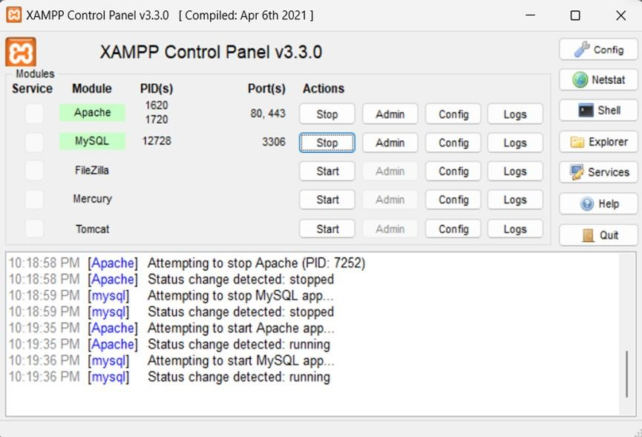

1. **HTML:**

HTML, or HyperText Markup Language, is the standard markup language used to create and design documents on the World Wide Web. It is a key component of web development and provides a structured way to format content on the web. HTML documents are interpreted by web browsers to display text, images, links, forms, and other elements.

1. **CSS:**

CSS, or Cascading Style Sheets, is a style sheet language used to describe the presentation and layout of HTML documents. It defines how elements should be displayed on the screen, in print, or in other media. CSS enables web developers to control the appearance of web pages, ensuring consistency and flexibility in the design across different devices and screen sizes.

1. **JavaScript:**

JavaScript is a high-level, versatile programming language primarily known for its use in web development. It allows developers to add interactivity, manipulate the DOM (Document Object Model), handle events, and create dynamic content on websites. JavaScript is an essential component of modern web development and is supported by all major web browsers.

1. **Laravel:**

Laravel is a free, open-source PHP web framework designed for the development of robust and maintainable web applications. It follows the Model-View-Controller (MVC) architectural pattern and provides elegant syntax and tools for tasks such as routing, caching, database interactions, and more. Laravel aims to make the development process enjoyable and efficient by emphasizing clean, expressive code.

1. **MySQL:**

MySQL is an open-source relational database management system (RDBMS) that is widely used for building and managing databases. It is a key component of the LAMP (Linux, Apache, MySQL, PHP/Python/Perl) and MERN stacks and is often used in conjunction with web applications. MySQL is known for its performance, reliability, ease of use, and strong community support.

# CHAPTER 3

## . CONTENT REVIEW

**Fashion-For-You** is an online platform designed to simplify the shopping experience for fashion items and accessories. This system assists users—ranging from casual shoppers to fashion enthusiasts—in browsing available products, comparing prices, and facilitating easy communication with vendors. Vendors benefit from a user-friendly tool to showcase their products, manage inventory, and handle customer inquiries efficiently.

Developed using React.js, HTML, CSS, and Node.js, with MySQL as the database management system, Fashion-For-You prioritizes simplicity and effectiveness. Resources like Stack Overflow and YouTube played a crucial role in developing various design components and event handling methods for the project. This platform aims to stabilize the fashion retail market by promoting positive and engaging interactions between customers and vendors.

## LITERATURE REVIEW

The **Fashion-For-You** platform represents a significant advancement in optimizing retail logistics in urban and suburban settings. Utilizing advanced web technologies, it provides real-time updates on product availability and order status. Research emphasizes its role in enhancing shopping efficiency, promoting flexibility, and contributing to sustainability by reducing excess inventory through better demand forecasting.

The integration of user-friendly interfaces and compatibility with existing ecommerce infrastructure is crucial for broad adoption. The literature also discusses the evolving landscape of online retail technologies, highlighting innovative features like personalized recommendations and predictive analytics. Ongoing studies aim to refine ecommerce systems to meet the diverse needs of various consumer demographics.

## RELATED WORKS

### Amazon

Amazon is a globally recognized ecommerce platform that has transformed online shopping. It allows users to browse a vast selection of products, compare prices, and receive recommendations based on their preferences. Amazon's user interface features real-time order tracking, transparent pricing, and secure payment methods.

### Ebay

EBay is another major player in the online retail industry, offering a convenient platform for buying and selling a wide range of items. Similar to Amazon, eBay allows users to list products, track their orders, and make secure payments. eBay distinguishes itself with its auction-style listings and community engagement features. The platform promotes sustainability through reselling and has a robust buyer protection program, ensuring a safe shopping experience for customers.

### Zolando

Zalando is a prominent online fashion retailer in Europe, offering a diverse range of clothing, footwear, and accessories. Its platform allows users to easily browse, track orders, and make payments digitally. Zalando's focus on personalized shopping experiences and integration of user-generated content enhances accessibility and customer engagement. The company's ongoing efforts to incorporate technology and improve service quality have established it as a leading fashion ecommerce solution in the region.

## SYSTEM DESIGN

### Admin Panel:

• **Dashboard:** A comprehensive overview of system activities and performance metrics.

•  **Vendor Management:** Handle registration, verification, and ongoing support for vendors.

• **Product Management:** Oversee product listings, inventory control, and updates.

• **Pricing Management:** Control and adjust pricing strategies and promotions.

• **System Configuration:** Options for platform customization and feature adjustments.

•  **Safety and Compliance:** Ensure adherence to regulations and enforce policies.

• **Integration and Expansion:** Facilitate third-party service integrations and enhance platform scalability.

• **Security Measures:** Implement data protection strategies and fraud prevention protocols.

### User or Client Panel:

• **Registration and Authentication:** Secure and straightforward account setup process.

• **Shopping Interface:** An intuitive process for browsing and purchasing fashion items.

• **Order Tracking:** Real-time monitoring of order status and delivery updates.

• **Payment Options:** Support for multiple payment methods for customer convenience.

• **Price Transparency:** Clear and transparent pricing information for all products.

• **Order History and Preferences:** Access to past purchases and personalized preferences.

• **Customer Support:** Multiple channels for assistance and inquiries.

• **Accessibility Features:** Considerations for diverse user needs, ensuring an inclusive shopping experience.

## MODULE DIAGRAM

Module Is a Diagrammatic Representation of a Functionality Within a Project. It May Have One or Many Modules in A Software. In Other Words, Module Is an Approach That Subdivides a System into Smaller Parts Called Module That Independently Created and Then Used in Different Systems.

FASHION-FOR-YOU

ECOMMERCE SITE

Homepage

Products

ECOMMERCE SITE

Login

Contact

ECOMMERCE SITE

About Us

ECOMMERCE SITE

Register

ECOMMERCE SITE

Admin dashboard

ECOMMERCE SITE

Admin Profile

ECOMMERCE SITE

Users Management

ECOMMERCE SITE

Products Management

ECOMMERCE SITE

Orders Management

SiteSetting Management

Logout

Homepage

ECOMMERCE SITE

User Profile

ECOMMERCE SITE

Products View

ECOMMERCE SITE

Add to Cart

ECOMMERCE SITE

Place Order

Order Tracking

Feedback

Logout

**1 Fig: Module diagram**

# CHAPTER 4

## 4.1. SYSTEM DEVELOPMENT MODEL

For any project to be completed, it has to go through stages called Development Life Cycles. System Development Life Cycle (SDLC) is the process of understanding how an Information System (IS) can support business needs, designing the system, building it and delivering it to users. The SDLC composes of four phases: Planning, Analysis, Design and Implementation In order for this project to be developed, the methodology that will be used is the System Structured Analysis and Design Methodology. Agile has gained a great deal of popularity. The model breaks down big projects into smaller, more manageable chunks, which can lead to a software product that represents a culmination of multiple, smaller projects. The model produces ongoing releases where each iteration includes small, incremental changes and improvements from the previous release.

**Uses:** Agile is particularly well-suited for large and complex projects; those that can be easily divided into smaller parts. It’s also useful for mid-size custom software development projects where business requirements cannot be easily translated into detailed requirements.

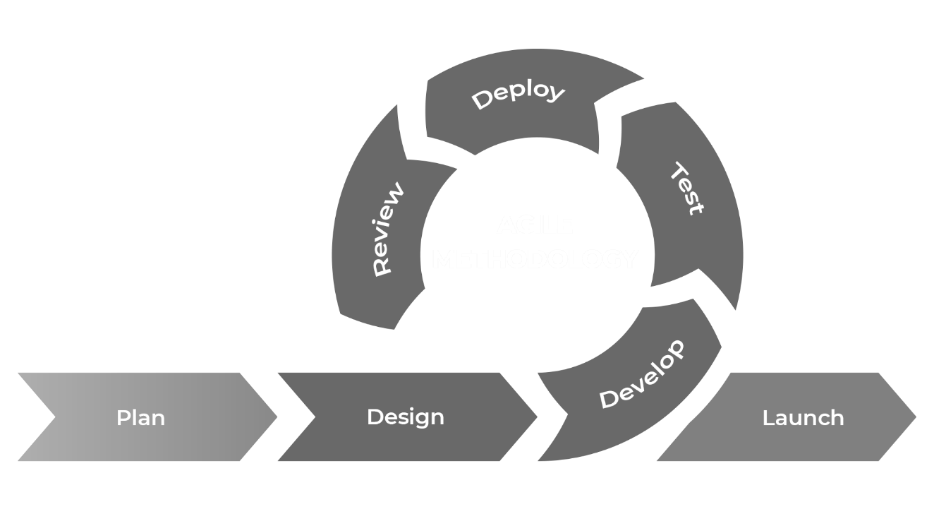

**2 Fig: Agile Model**

## 4.2. FLOW CHART

A flowchart is a graphical representation of a process. It’s a diagram that illustrates the workflow required to complete a task or a set of tasks with the help of symbols, lines and shapes. Flowcharts are used to study, improve and communicate processes in various fields.

* **Symbols used in flowchart**

|  |  |  |
| --- | --- | --- |
| **Symbols** | **Names**  Oval  Rectangle  Parallelogram  Arrow | **Description**  Represents the start and end of the process**.**  It is used to represent the process.  It is used to represent the input and output of the flowchart.  It shows relationship between the representative shapes. |

### LOGIN FORM



Input Admin

Or

User information



Check Username

&

Password



Display Selected

Form



Start

End

Display Error

Message

NO

Yes

**3 Fig: Login form**

### REGISTER FORM



Input all Information of User



Check Information in the Database



Display Selected

Form



Start

End

Display Error

Message

Yes

No

**4 Fig: Register Form**

### INSERT DATA

Input Data

If pass

match

No

Error message

Yes

Save To Database

**5 Fig: Insert Data**

### UPDATE DATA

Input Update Data

Confirm

Save To Database

**6 Fig: Update Data**

### DELETE DATA

Select Data

Confirm

Display Message

Data is deleted

**7 Fig: Delete Data**

### PRODUCT DATA DETAILS



Yes



End



N

o



Start



Input Product

Information



Check Product

Product ID in

the database table



Display

Source Message



Insert, Select, Update,

Delete, New data of

Product in the database table



Display Error

Message

**8 Fig: Product Data Details**

## ER DIAGRAM

An Entity Relationship Diagram (ER Diagram) pictorially explains the relationship between entities to be stored in a database. Fundamentally, the ER Diagram is a structural design of the database. It acts as a framework created with specialized symbols for the purpose of defining the relationship between the database entities. ER diagram is created based on three principal components: entities, attributes, and relationships.

### Admin Management

Manages

Users

Admin

**9 Fig: Admin Manages User/Visitors**

Manages

Products

Admin

**10 Fig: Admin Manages Products**

### User`s Management

Manages

Users Profile

Users

**11 Fig: Users Manages Profile**

Place Order

Products

Users

**12 Fig: Users Purchases Products**

## DATA FLOW DIAGRAM (DFD DIAGRAM).

DFD is the abbreviation for Data Flow Diagram**.** The flow of data of a system or a process is represented by DFD. It also gives insight into the inputs and outputs of each entity and the process itself. DFD does not have control flow and no loops or decision rules are present. Specific operations depending on the type of data can be explained by a flowchart. It is a graphical tool, useful for communicating with users, managers and other personnel. it is useful for analyzing existing as well as proposed system.

|  |  |
| --- | --- |
| **Symbols** | **Description**  It is represented by a circle and depicts how the data is handled and processed in the system.  It represents entity and simply depicts a source or termination of the diagram by mapping real-world entities.  Two parallel lines represent location where data is stored in the system.  Directional lines depict the flow of data from one location to another. |

### DFD-Level 0 (Context Diagram)

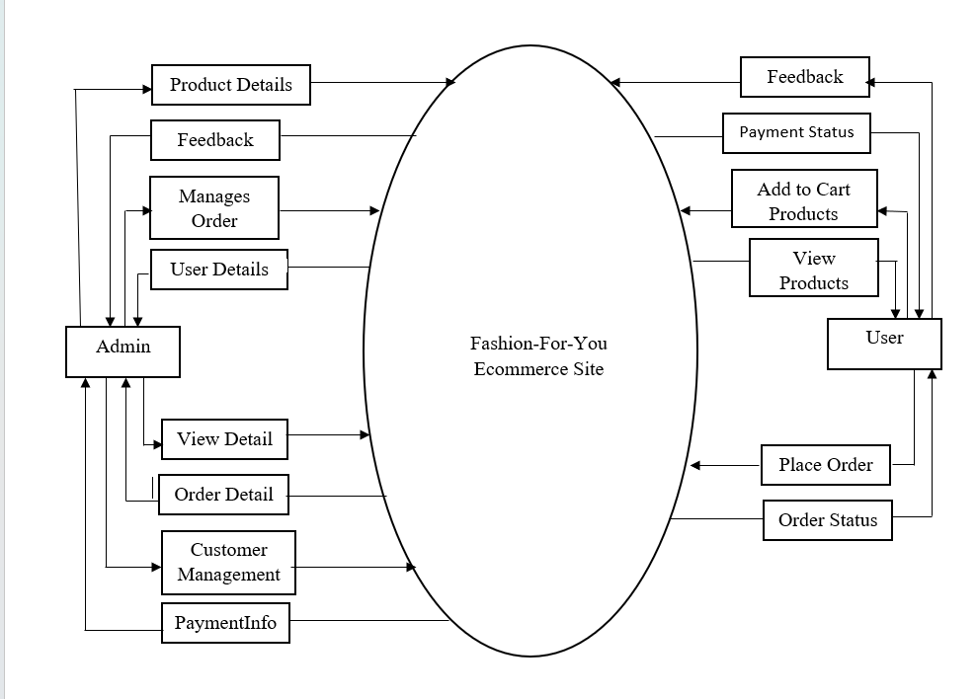

**13 Fig: DFD-Level 0 (Context Diagram)**

### DFD-Level 1 ( Add to Cart Management ) Diagram

Product Details

Add, save, update, delete

Changes Product Details

Admin

Place Order

Manages cart products

**14 Fig: DFD Level-1 ( Add to Cart Management ) Diagram**

### DFD-Level 1 ( Login System ) Diagram

Login

Authentication

Check Username

Login

Logout

Feedback

Username, Password

Login

**15 Fig: DFD level-1 ( Login System ) Diagram**

## DATABASE SCHEMA DIAGRAM

A database schema diagram is a visual representation of the structure of a database. It outlines the various tables within the database, the fields (or attributes) within those tables, and the relationships between the tables. This diagram serves as a blueprint for the database design and helps in understanding how data is organized and how different data entities interact with each other.

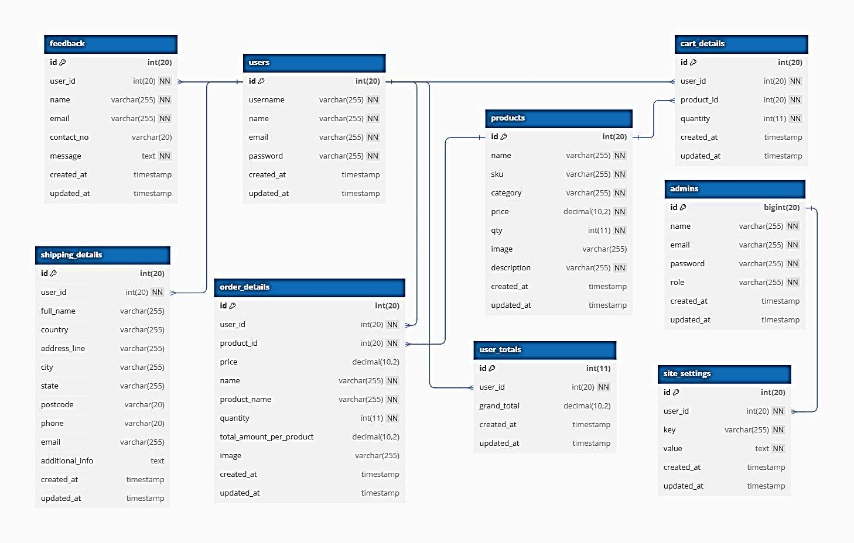

**16 Fig: Database Schema Diagram**

## USER INTERFACE

## HomePage

**17** Fig: USER DASHBOARD

**17 Fig: Homepage**

## Products List Page

**18 Fig: Products List page**

## Login Page

**19 Fig: Login Page**

## Register Page

**20 Fig; Register Page**

## Team Members

**21 Fig: Team Members**

## ADMIN DASHBOARD

## Profile Update Page

**22 Fig: Profile Update Page**

## Add Products Page

## 7.3.

**23 Fig: Add Products Page**

## Order List Page

**24 Fig: Order List Page**

## Site Settings Page

**25 Fig: SiteSettings Page**

## CODES

## Login Code

**Fig: Login Code**

## Register

**Fig: Register Code**

## Add Product

**Fig: Add product**

## Delete Product

**Fig: Delete Code**

## Update Product

**Fig: Update Code**

## Add to Cart

**Fig: Add to cart Code**

## Checkout and Payment using Stripe

**Fig: Checkout and payment Code**

1. **SYSTEM TESTING**

System testing for our Fashion-for-You online platform involves evaluating the integrated system to ensure it meets the specified requirements and functions as expected. Here’s an overview of the key aspects considered during the system testing phase:

* Functional Testing:

Verify that all functional requirements are implemented correctly. Test user registration and authentication processes, ensuring the product search, filtering, and checkout functionalities work seamlessly.

* User Interface (UI) Testing:

Evaluate the user interface for usability, responsiveness, and adherence to design specifications. Confirm that buttons, links, and interactive elements function as intended.

* Performance Testing:

Assess the application’s performance under various conditions. Measure response times for key functionalities to ensure a smooth shopping experience.

* Security Testing:

Identify and address security vulnerabilities to protect user data. Verify secure communication, especially during payment transactions, to safeguard sensitive information.

* Compatibility Testing:

Confirm that the Fashion-for-You platform functions correctly across different browsers, devices, and operating systems. Ensure compatibility with various devices, including desktops, laptops, tablets, and smartphones.

* Database Testing:

Ensure the integrity and reliability of the database. Test data retrieval and storage operations, verify that database queries are optimized for efficiency, and check the handling of concurrent transactions and data consistency.

1. **SYSTEM MAINTENANCE**

System maintenance is essential for ensuring the ongoing functionality, security, and usability of the Fashion-for-You platform. It involves monitoring, updating, and enhancing the system to adapt to changing requirements and address issues that may arise over time.

* Monitoring and Incident Response:

Implement continuous monitoring to promptly detect and address any system anomalies or security incidents. Establish an incident response plan to efficiently handle and resolve issues as they arise.

* Regular Software Updates:

Keep the application’s software stack, including operating systems, frameworks, and third-party libraries, up to date to mitigate security vulnerabilities and take advantage of the latest features and optimizations.

* Database Maintenance:

Perform routine database maintenance tasks, such as optimizing queries, updating indexes, and managing data backups, to ensure data integrity and efficient performance.

* User Feedback and Support:

Create channels for users to provide feedback on their experiences with the platform. Address user-reported issues promptly and provide ongoing support to maintain high user satisfaction.

* Scalability and Performance Optimization:

Monitor system performance and scalability to anticipate and resolve any bottlenecks as user traffic grows. Optimize code and database queries to enhance overall system performance.

* Regulatory Compliance:

Stay informed about changes in relevant legal and regulatory requirements to ensure ongoing compliance with data protection laws and other industry-specific regulations.

## CONCLUSION

In conclusion, the **Fashion-for-You** online platform signifies a substantial evolution in the retail industry, delivering a convenient and efficient solution for purchasing clothing and accessories through a web-based interface. By incorporating various modules such as user management, product catalog management, order processing, and secure payment handling, the system offers a seamless shopping experience for customers, sellers, and administrators alike.

Ultimately, **Fashion-for-You** aspires to transform the retail landscape by leveraging technology to streamline the shopping process, enhance user experience, and boost operational efficiency. As technology continues to advance, the platform is well-positioned to adapt and innovate, providing an essential solution for fashion enthusiasts and retailers alike.

## REFRENCES

[1] “W3Schools,” [Online]. Available: https://www.w3schools.com/. [Accessed 18 Sep 2024].

[2] “Wikipedia,” [Online]. Available: https://www.wikipedia.com/. [Accessed 22 Sep 2024].

[3] “JavaTpoint,” [Online]. Available: https://www.javatpoint.com/. [Accessed 25 Sep 2024].

[4] “YouTube,” [Online]. Available: https://www.youtube.com/. [Accessed 30 Sep 2024].

[5] “Bootstrap,” [Online]. Available: https://getbootstrap.com/. [Accessed 23 Sep 2024].

[6] “Shopify,” [Online]. Available: https://www.shopify.com/. [Accessed 26 Sep 2024].

[7] “Magento,” [Online]. Available: https://magento.com/. [Accessed 15 Sep 2024].

[8] “ChatGPT,” [Online]. Available: https://chat.openai.com/. [Accessed 27 Sep 2024].

[9] “diagrams.net,” [Online]. Available: https://app.diagrams.net/. [Accessed 29 Sep 2024].

[11] “Ecommerce Platforms,” [Online]. Available: https://ecommerce-platforms.com/. [Accessed 24 Sep 2024].